**[11:00-11:20] Recap: Fourier series analysis and synthesis**

Any periodic signal can be represented as a weighted sum of complex sinusoids. For a real-valued periodic signal, the Fourier series coefficients will have conjugate symmetric amplitudes, meaning that the Fourier series coefficients for the negative frequencies are equal to the complex conjugate of coefficients corresponding to the positive frequencies.

The Fourier series coefficients $a_{k}$ can be computed from a periodic signal $x(t)$ by integration over one fundamental period $T_{0}$:

$$\begin{aligned}a_{k}=\frac{1}{T_{0}}\underset{\begin{aligned}extracts the component of x\left(t\right) that \\ looks like a complex sinusoid e^{-j2πkf_{0}t}\end{aligned}}{\underbrace{\int_{0}^{T_{0}}{x\left(t\right)e^{-j2πkf_{0}t}dt}}}\#\left(Fourier series analysis\right)\end{aligned}$$

Fourier series analysis can often be performed without any integration by eyeballing:

Example:

$$x\left(t\right)=\cos^{2}\left(2πf_{0}t\right) \\ =\underset{\begin{aligned}average \\ value\end{aligned}}{\underbrace{ \frac{1}{2} }}+\frac{1}{2}\underset{\begin{aligned}zero average value \\ over the fundamental period\end{aligned}}{\underbrace{\cos\left(2π\left(2f_{0}\right)t\right)}} \\ =\frac{1}{2}+\frac{1}{4}e^{j2π2f_{0}t}+\frac{1}{4}e^{-j2π2f_{0}t}$$

Thus, the Fourier series coefficients are:

$$a_{0}=\frac{1}{2}, a_{2}=\frac{1}{4}, a_{-2}=\frac{1}{4}$$

A periodic signal can be synthesized by adding together complex exponentials weighted by the Fourier series coefficients $a_{k}$:

$$\begin{aligned}x\left(t\right)=\sum_{k=-∞}^{∞}{a_{k}e^{j2πkf_{0}t}}\#\left(Fourier series synthesis\right)\end{aligned}$$

**[11:20-11:50] Fourier analysis of a square wave**

$$s\left(t\right)=\left\{\begin{matrix}1 & 0≤t<\frac{1}{2}T_{0} \\ 0 & \frac{1}{2}T_{0}≤t<T_{0}\end{matrix}\right.$$

$a_{0}=\frac{1}{2}$ because the average value is ½.

$$a_{k}=\int_{0}^{T_{0}}{x\left(t\right)e^{-j2πkf_{0}t}dt}=\underset{\frac{T_{0}}{2} to T_{0} is zero}{\underbrace{\int_{0}^{\frac{T_{0}}{2}}{x\left(t\right)e^{-j2πkf_{0}t}dt}}}=\underset{\begin{aligned}Integral of an exponentlal. \\ You can also use MATLAB or another \\ symbolic math program to solve this.\end{aligned}}{\underbrace{\left(\frac{1}{T_{0}}\right){\left.\frac{e^{-j2πkf_{0}t}}{-j2πkf_{0}}\right|}_{0}^{\frac{1}{2}T_{0}}=\frac{1-{\left(-1\right)}^{k}}{j2πk}}}$$

Example: Hz.

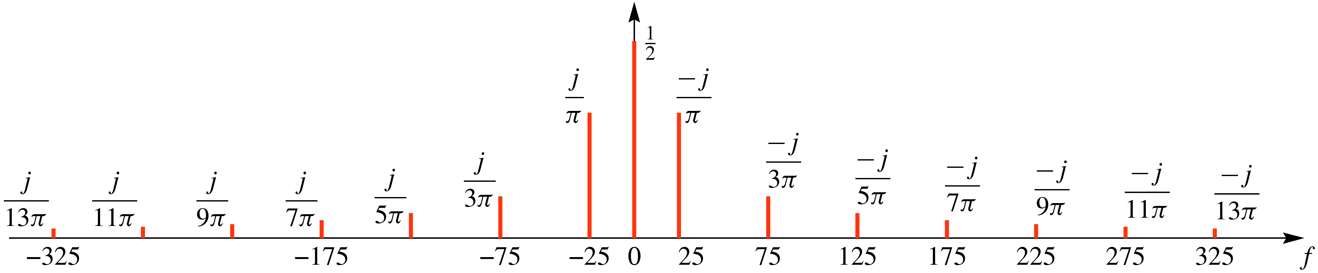

Q: Why are there only sine terms in the expansion?

A: Both the sine function and $s(t)$ are odd symmetric. In general, an odd symmetric signal will only have sine terms in its Fourier series representation. An even symmetric signal will only have cosine terms in its Fourier series representation.

**[11:50-12:00] Demo and Gibbs phenomenon**

In the reconstruction of the square wave, the Fourier-synthesized signal never converges around the discontinuities (the rising and falling edges of the square wave). This is known as Gibbs phenomenon. This only occurs for signals with discontinuities---it does not occur, for example, with a triangle wave.

**[12:00-12:20] Time-Frequency Spectrum**

Fourier series synthesis only works for infinite length periodic signals. In practice, most signals change over time. A common example is music. Instead of using a purely time-domain or purely frequency domain representation, Sheet music provides a joint time-frequency representation:

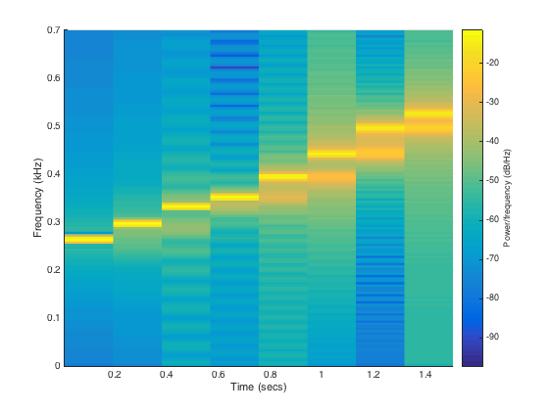A magnitude spectrogram is another type of time-frequency representation that maps the intensity to a brightness or color. To construct a spectrogram, we first divide the signal into short segments, then compute the Fourier series for each segment assuming it’s periodic extension (also called the DFT).

